ggplot2 is go-to R package for anyone who wants to make beautiful static visualizations in R. But most ggplot2 gplots look almost the same and little many data analysts or data scientists care about customizing it, primarily because it’s not very intuitive to do so. That’s where ggplot2 extensions come in very handy. ggtext is an R package (by *Claus O. Wilke*) that helps in customizing the text present in ggplot2 plots. It could be the text outside the plot canvas or the text (annotation) within the plot canvas.

**Code**

library(ggtext)

library(ggplot2)

ggplot(iris) +

geom_point(aes(x = Sepal.Length,

y = Petal.Length)) +

facet_wrap(~ Species) +

theme(

strip.text = element_textbox(

size = 12,

color = "white", fill = "red", box.color = "black",

halign = 0.5, linetype = 1, r = unit(5, "pt"), width = unit(1, "npc"),

padding = margin(2, 0, 1, 0), margin = margin(3, 3, 3, 3)

)

)

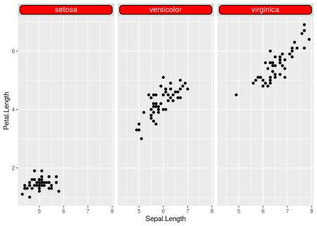

library(ggtext)

library(ggplot2)

ggplot(iris) +

geom_point(aes(x = Sepal.Length,

y = Petal.Length)) +

facet_wrap(~ Species) +

theme(

strip.text = element_textbox(

size = 12,

color = "white", fill = "red", box.color = "black",

halign = 0.5, linetype = 1, r = unit(5, "pt"), width = unit(1, "npc"),

padding = margin(2, 0, 1, 0), margin = margin(3, 3, 3, 3)

)

)

library(ggplot2)

library(ggtext)

ggplot(iris) +

geom_point(aes(x = Sepal.Length,

y = Petal.Length)) +

labs(title = "**iris analysis**

*super*") +

theme(

plot.title = element_textbox_simple(

fill = 'yellow',

padding = margin(5.5, 5.5, 5.5, 5.5) )

)

ggplot(mtcars, aes(disp, mpg)) +

geom_point() +

labs(

title = "**Fuel economy vs. engine displacement**

Lorem ipsum *dolor sit amet,*

consectetur adipiscing elit, **sed do eiusmod tempor incididunt** ut

labore et dolore magna aliqua. Ut enim

ad minim veniam, quis nostrud exercitation ullamco laboris nisi

ut aliquip ex ea commodo consequat.",

x = "displacement (in3)",

y = "Miles per gallon (mpg)  
A measure of

the car's fuel efficiency."

) +

theme(

plot.title.position = "plot",

plot.title = element_textbox_simple(

size = 13,

lineheight = 1,

padding = margin(5.5, 5.5, 5.5, 5.5),

margin = margin(0, 0, 5.5, 0),

fill = "cornsilk"

),

axis.title.x = element_textbox_simple(

width = NULL,

padding = margin(4, 4, 4, 4),

margin = margin(4, 0, 0, 0),

linetype = 1,

r = grid::unit(8, "pt"),

fill = "azure1"

),

axis.title.y = element_textbox_simple(

hjust = 0,

orientation = "left-rotated",

minwidth = unit(1, "in"),

maxwidth = unit(2, "in"),

padding = margin(4, 4, 2, 4),

margin = margin(0, 0, 2, 0),

fill = "lightsteelblue1"

)

)